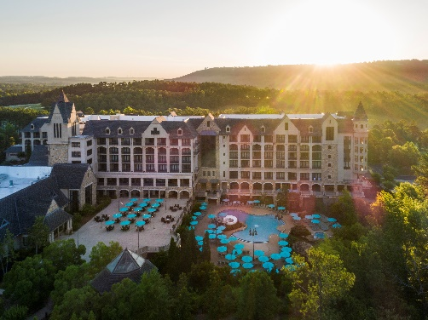
ANNUAL
2022
MEETING &
FALL PEDIATRIC
UPDATE

September 9 – 11, 2022
Ross Bridge Resort, Birmingham, AL & Via Zoom

AGENDA
RKSHOP
Friday, September 9 (Exhibits Open 4:45 p.m. – 6:30 p.m.)
Executive Board Meeting 8:30 – 11:30 a.m. Pelham
Practice Management Association (PMA) Annual Meeting: Salons FGH
Registration and Continental Breakfast 7:30 – 8:00 a.m.
Annual Meeting 8:00 – 9:00 a.m.
Break/Transition to Practice Management Workshop 9:00 – 9:10 a.m.
Practice Management Workshop (open to pediatricians and their staffs):
Delivering on Your Practice Culture Salons FGH
—Chip Hart 9:10 – 10:00 a.m.
Regulatory Update on Pediatric and Adolescent Medicine Salons FGH
—Brandy Boone, JD 10:00 – 11:00 a.m.
Alabama Medicaid in 2022: What Pediatricians
and their Staffs Need to Know Salons FGH
—Barry Cambron 11:00 – 11:45 a.m.
Break & Transition to Lunch 11:45 – 12:00 p.m.
Lunch & Session:
Alabama Pediatric Practice Management Hot Topics Salons FGH
—Facilitated by Leslie Sawyer, MD, FAAP 12:00 – 12:45 p.m.
The Magic of Tidying Up: Simplify Your LIfe and
Practice to Find More Joy Salons FGH
— Katrina Skinner, MD, FAAP 12:45 – 1:45 p.m.
The Pediatrician’s Role in Caring for Infants Who are Deaf or
Hard of Hearing & What’s New in AL Newborn Screening Salons FGH
— DeeAnne Jackson, MD, FAAP; Mary Whigham 1:45 – 2:45 p.m.
Exhibit Set-Up 2:30 – 4:00 p.m. Salons ABCD
Main Meeting Registration 2:30 – 6:30 p.m. Foyer
Break 2:45 – 3:00 p.m.
Main Meeting:
Healing-Centered Support for Families Experiencing Intimate Partner Violence
—Kimberly Randell, MD, MSc, FAAP, Taneshia Hannon 3:00 – 4:00 p.m. Salons FGH
Updates on Suicide Prevention
— Ana Radović, MD, MSc 4:00 – 5:00 p.m. Salons FGH

“Meet and Greet” Reception in the Exhibits 4:45 – 6:30 p.m. Salons ABCD

Saturday, September 10 (Exhibits Open 7:15 a.m. – 1:00 p.m.)
Registration 7:00 – 8:00 a.m. Foyer
Breakfast in the Exhibits 7:15 – 8:00 a.m. Salons ABCD
Welcome
Functional Abdominal Pain Disorders
— Diana Montoya Melo, MD, FAAP 8:00 – 9:00 a.m. Salons EFGH
Technology and Adolescent Mental Health
— Ana Radović, MD, MSc 9:00 – 9:45 a.m. Salons EFGH
Refreshment Break in the Exhibits 9:45 – 10:15 a.m. Salons ABCD
Mental Health Services for Children in Alabama: Supporting the Pediatric Medical Home
—Marissa Grayson, Susan Griffin, Emily Herring, Cindy Jones 10:15 – 11:15 a.m. Salons EFGH
Chapter Annual Meeting/Reports (non-CME)
—Chapter Leadership 11:15 – 11:45 p.m. Salons EFGH
Educational Lunch Program / Industry-Sponsored Symposium (not part of Chapter CME):
Developmental Delays in Early Childhood – Is It Duchenne Muscular Dystrophy (DMD)
—Sponsored by Sarepta Therapeutics 11:45 – 12:45 p.m. Salons EFGH
Strolling Dessert in the Exhibits 12:45 – 1:15 p.m. Salons ABCD
Exhibit breakdown 1:15 – 1:45 p.m.
US Preventive Service Task Force Recommendation B for Fluoride for Pediatricians?
— Patricia Braun, MD, MPH, FAAP 1:15 – 2:00 p.m. Salons EFGH
Asthma: Guidelines Update
— Eliane F. Eakin, MD, PhD, FAAP, FCCP 2:00 – 3:00 p.m. Salons EFGH

Free Time 3:00 – 4:00 p.m.

Reception and 6:30 – 7:00 p.m. Salons ABCD
Awards Dinner
—Sponsored/Co-hosted by Children’s of Alabama 7:00 – 8:30 p.m. Salons ABCD

Sunday, September 11
Breakfast 7:30 – 8:00 a.m. Foyer
Preventing Caries: Elevating Children to Break Down a Major Health Inequity
— Patricia Braun, MD, MPH, FAAP 8:00 – 9:00 a.m. Salons EFGH
Endocrine Updates for the Pediatrician
—Heather Choat, MD, MS, FAAP 9:00 – 10:00 a.m. Salons EFGH
Multisystem Inflammatory Syndrome in Children (MIS-C): An Update
—Daniel Reiff, MD, FAAP 10:00 – 11:00 a.m. Salons EFGH
One Too Many Fevers - Evaluation of Recurrent Fever in Children
— Melissa L. Mannion, MD, MSPH 11:00 – 12:00 p.m. Salons EFGH
Adjourn 12:00 p.m.

